**Name: Classwork 10.2**

**More Practice with Home Price Data**

1. Create a model that uses the size of the home to explain some of the variation in price.
   1. Explore this bivariate relationship with a visualization.

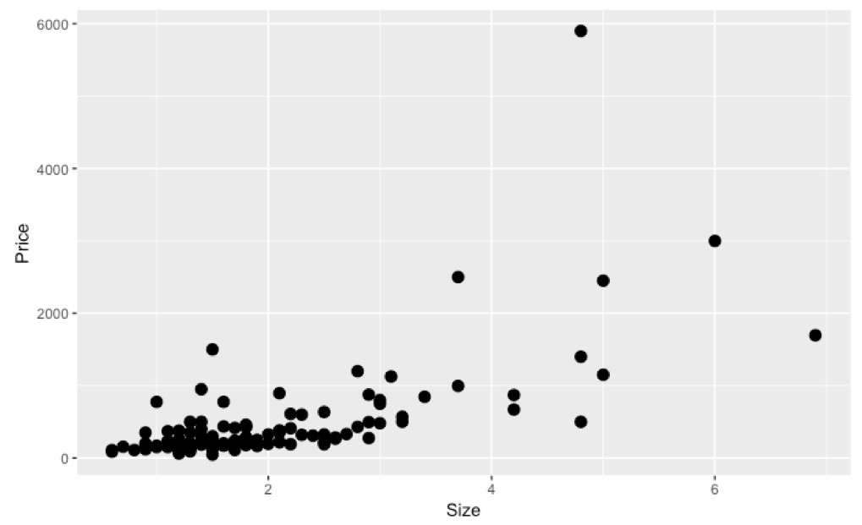

* 1. Specify a model (that’s the GLM notation part!).
  2. Fit the model (that’s filling in the numbers!).
  3. Interpret the best fitting estimates.

**Data versus Predicted**

1. If we use the predict() function with our complex model, would it give us the same line as the regression line (e.g., gf_lm)? How is it similar? How is it different? What does the line really mean?
2. If we use the predict() function with our empty model, would it give us the same line as the horizontal line with the mean of Price (e.g., gf_hline)? How is it similar? How is it different? What does the line really mean?
3. How do we put the predictions on top of our scatterplot in R?

**Residuals versus Sum of Squares**

1. What’s the difference between the residuals and the sum of squares?

**R versus PRE (aka R2)**

1. What to know about R (correlation coefficient):

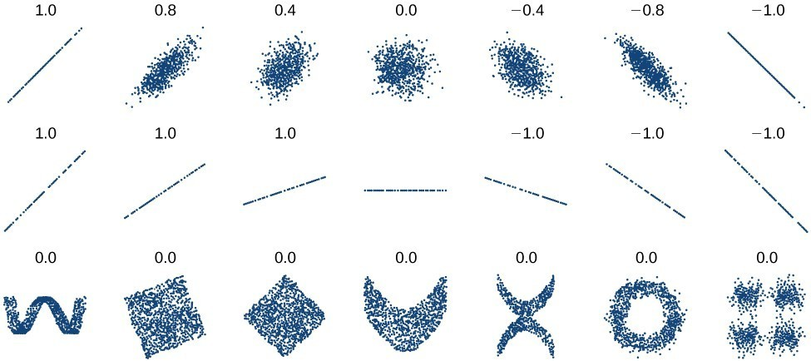

1. Our class: We prefer to make relationships more clear than to obfuscate. Let’s learn how to translate to other classes.
   1. Other people will mention R2 (R-squared). What is that in our class?
   2. Other people will mention $η^{2}$ (eta-squared). What is that in our class?
   3. Statistical knowledge does not run deep. Tell people you are following the Judd and McClelland approach to model comparison and thus prefer to use the more generalizable PRE rather than R2 and (eta-squared).